root@ds-tcb-prod-mvno-1:~# ufw status verbose
Status: inactive
root@ds-tcb-prod-mvno-1:~#

https://www.cyberciti.biz/faq/ubuntu-server-disable-firewall/

Disable / Turn Off Firewall in Ubuntu Linux Server
last updated August 3, 2015 in CategoriesIptables, Linux, Ubuntu Linux

How do I disable the firewall in Ubuntu Linux server edition? How do I turn off the firewall in Ubuntu Linux version 12.04 or 14.04 LTS server?

The latest version of Ubuntu comes with a program called ufw. It is used for managing a Linux firewall and aims to provide an easy to use interface for the user.

A Note About ufw
As I said earlier, the latest version of Ubuntu comes with ufw (now it is the default firewall configuration tool for Ubuntu). It is developed to ease iptables firewall configuration, ufw provides a user friendly way to create an IPv4 or IPv6 host-based firewall.

List ufw firewall rules, enter:
$ sudo ufw status verbose
Sample outputs:
Status: active
Logging: on (low)
Default: deny (incoming), allow (outgoing), deny (routed)
New profiles: skip
To Action From
-- ------ ----
71.81.22.14 80/tcp ALLOW IN Anywhere
71.81.22.15 80/tcp ALLOW IN Anywhere

To disable ufw based firewall, enter:
$ sudo ufw disable

List current firewall rules and stop firewall (old method)
You can type the following command to see if firewall is active or not (open a terminal or ssh session and type the following command):
$ sudo iptables -L -n
Sample outputs:
Chain INPUT (policy ACCEPT)
target prot opt source destination
ACCEPT udp -- 0.0.0.0/0 0.0.0.0/0 udp dpt:53
ACCEPT tcp -- 0.0.0.0/0 0.0.0.0/0 tcp dpt:53
ACCEPT udp -- 0.0.0.0/0 0.0.0.0/0 udp dpt:67
ACCEPT tcp -- 0.0.0.0/0 0.0.0.0/0 tcp dpt:67
Chain FORWARD (policy ACCEPT)
target prot opt source destination
ACCEPT all -- 0.0.0.0/0 192.168.122.0/24 state RELATED,ESTABLISHED
ACCEPT all -- 192.168.122.0/24 0.0.0.0/0
ACCEPT all -- 0.0.0.0/0 0.0.0.0/0
REJECT all -- 0.0.0.0/0 0.0.0.0/0 reject-with icmp-port-unreachable
REJECT all -- 0.0.0.0/0 0.0.0.0/0 reject-with icmp-port-unreachable
Chain OUTPUT (policy ACCEPT)
target prot opt source destination
You can save existing firewall rules as follows:
$ sudo iptables-save > firewall.rules
Finally, type the following commands to stop firewall and flush all the rules:
$ sudo iptables -X
$ sudo iptables -t nat -F
$ sudo iptables -t nat -X
$ sudo iptables -t mangle -F
$ sudo iptables -t mangle -X
$ sudo iptables -P INPUT ACCEPT
$ sudo iptables -P FORWARD ACCEPT
$ sudo iptables -P OUTPUT ACCEPT

A note about GUI tools for Ubuntu desktop systems
You can also use GUI tool to enable or disable Firewall under Ubuntu Linux desktop edition by visiting System > Administration > Firewall configuration option:
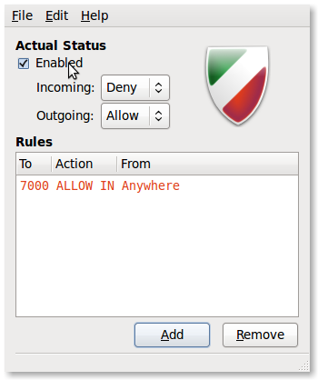Fig.01: Disabling Firewall In Ubuntu Linux
Simply unselect “Enabled” option to turn off the firewall.

Posted by: Vivek Gite

#
# 20190314
#
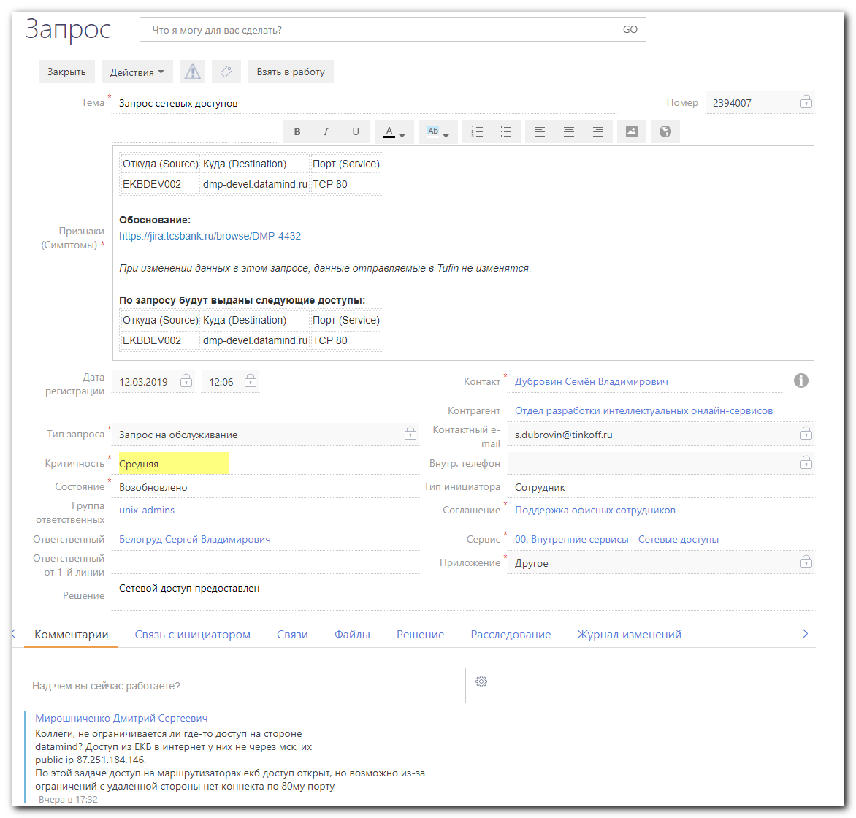

# I’ve connected to bk1.daamind.ru with a ssh key, previously saved in my MobaXterm.
bsv@bk1:~$ ssh bsv@dmp-devel.datamind.ru
bsv@dmp-devel:~$ sudo -i
[sudo] password for bsv:
root@dmp-devel ~ #

root@dmp-devel ~ # iptables -A INPUT -s 87.251.184.146/32 -j ACCEPT
root@dmp-devel ~ # iptables-save | grep -ie "87.251.184.146"
-A INPUT -s 87.251.184.146/32 -j ACCEPT
root@dmp-devel ~ # ls -Alh /etc/iptables/
total 16K
-rw-r--r-- 1 root root 8.1K Aug 10 2017 rules.v4
-rw-r--r-- 1 root root 183 Jun 7 2016 rules.v6
root@dmp-devel ~ #

# To make iptables persistant, were added two lines.
root@dmp-devel ~ # vim /etc/iptables/rules.v4
…
# SD#2394007 Allow access from Ekaterinburg
-A INPUT -s 87.251.184.146/32 -j ACCEPT
…

#
# But one mistake was happened.
# Added by me rules was placed after reject rule. In this case my rule was not worked.
root@dmp-devel ~ # iptables-save
# Generated by iptables-save v1.6.0 on Thu Mar 14 16:49:29 2019
*filter
...
-A INPUT -j REJECT --reject-with icmp-host-prohibited
-A INPUT -s 87.251.184.146/32 -j ACCEPT
...

# To return proper order, I’ve run “netfilter-persistent reload”
# But all docker iptables rules were lost… - that’s the fact!

#
# Here is how iptables rules was made persistant with oficial software.
root@dmp-devel ~ # ls /etc/init.d/netfilter*
netfilter-persistent
root@dmp-devel ~ #

#
# Here is experience to reload iptables rules.
root@dmp-devel ~ # netfilter-persistent --help
Usage: /usr/sbin/netfilter-persistent (start|stop|restart|reload|flush|save)
root@dmp-devel ~ # netfilter-persistent reload
run-parts: executing /usr/share/netfilter-persistent/plugins.d/15-ip4tables start
run-parts: executing /usr/share/netfilter-persistent/plugins.d/25-ip6tables start
root@dmp-devel ~ #

#
# https://dev-notes.eu/2016/08/persistent-iptables-rules-in-ubuntu-16-04-xenial-xerus/
#
Persistent Iptables Rules in Ubuntu 16.04 Xenial Xerus
Aug 07, 2016
Firewall, Iptables, Linux, Security, Server, Sysadmin
David Egan
The process of persisting firewall rules in Ubuntu 16.04 is different to the procedure for 14.04.

The Firewall setup is broadly the same as for 14.04 as described here.

This article briefly describes how to import a set of rules for IPtables and make these rules persist across reboots.

EXPORT RULES
If you’re exporting a ruleset from an existing Ubuntu 14.04 server, log in to this machine. Assuming that the iptables-persistent package is installed, run the following commands:

sudo iptables-save > ~/iptables-rules/ruleset-v4
sudo ip6tables-save > ~/iptables-rules/ruleset-v6
Copy these ruleset files across to a temporary location on your Ubuntu 16.04 server.

INSTALL IPTABLES-PERSISTENT
# Install package
sudo apt-get install iptables-persistent

# Start - Thanks to Dave Wood for the correction in the comments section
sudo service netfilter-persistent start

#Add to startup
sudo invoke-rc.d netfilter-persistent save

# Stop the service
sudo service netfilter-persistent stop
IMPORT RULES
# Import Rules
sudo iptables-restore < ~/serenity-iptables-rules/ruleset-v4
sudo ip6tables-restore < ~/serenity-iptables-rules/ruleset-v6

# Check iptables
sudo iptables -S
SAVE RULES
To save the imported rules, run the iptables-persistent dpkg-reconfigure script:

sudo dpkg-reconfigure iptables-persistent
NOTE: The commands sudo netfilter-persistent save and sudo netfilter-persistent reload should work, but we’ve had problems with these commands and resorted to the dpkg-reconfigure option. It may be that a restart of the service is necessary after running these commands.

The dpkg-reconfigure causes iptables-persistent to repeat the install procedure - it will prompt for you to save the current rules. The current iptables rules will be saved into a file by means of iptables-save >/etc/iptables/rules.v4 and ip6tables-save >/etc/iptables/rules.v6. You should see your rules in /etc/iptables/rules.v4 and /etc/iptables/rules.v6.

The iptables-persistent package causes the following to run on reboot:

iptables-restore < /etc/iptables/rules.v4
ip6tables-restore < /etc/iptables/rules.v6

